Terraform
1). Install Terraform on your PC
1. Download Terraform
https://releases.hashicorp.com/terraform/1.16.1/terraform_1.16.1_windows_386.zip
Open the official HashiCorp Terraform installation page:
Terraform Installation
2. Extract the ZIP file
After downloading, extract it.
You will get:
terraform.exe
Create a folder:
C:\Terraform
Move terraform.exe into:
C:\Terraform\terraform.exe
3. Add Terraform to PATH
1. Press Windows + S
2. Search for Environment Variables
3. Click Edit the system environment variables
4. Click Environment Variables
5. Under System variables, select Path
6. Click Edit
7. Click New
8. Add:
C:\Terraform
9. Click OK on all windows.
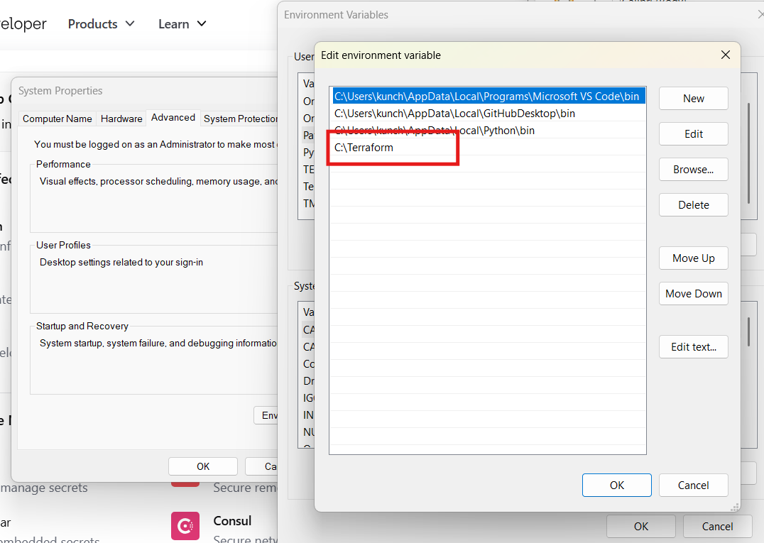
4. Verify Terraform installation
Open a new Command Prompt or PowerShell window or git bash
Run: terraform version and where terrafor
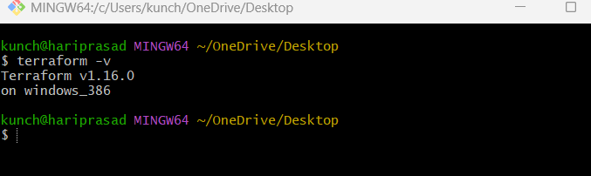
2). Execute all the templates shown in video.
Terraform init: Initializes the Terraform working directory and downloads required providers/modules.
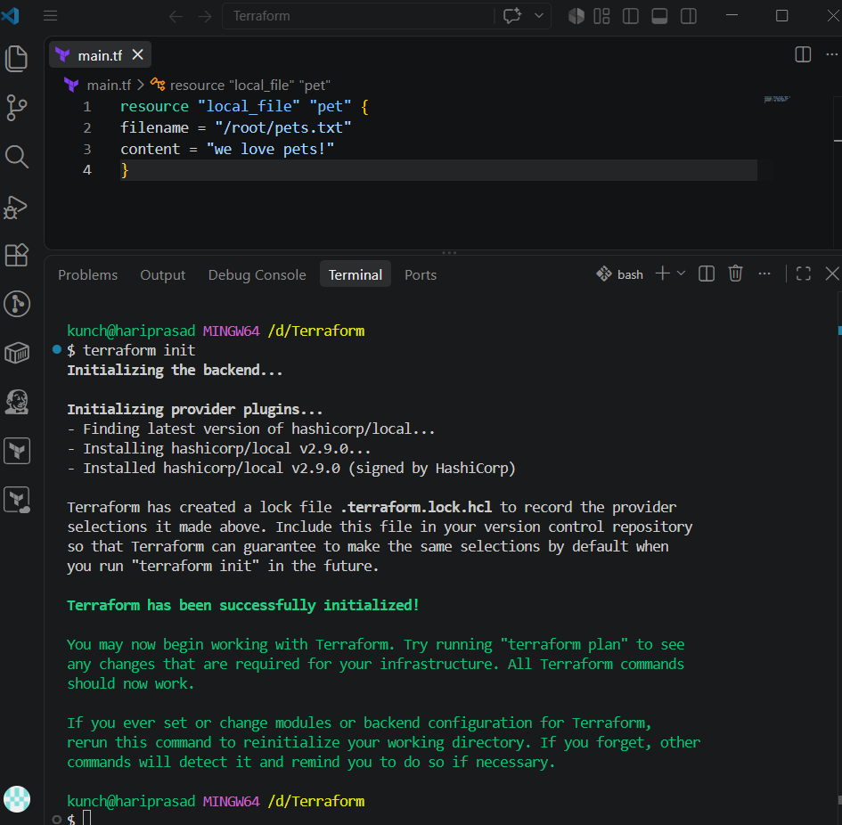
Terraform plan: Shows what changes Terraform will make before creating or modifying resources.
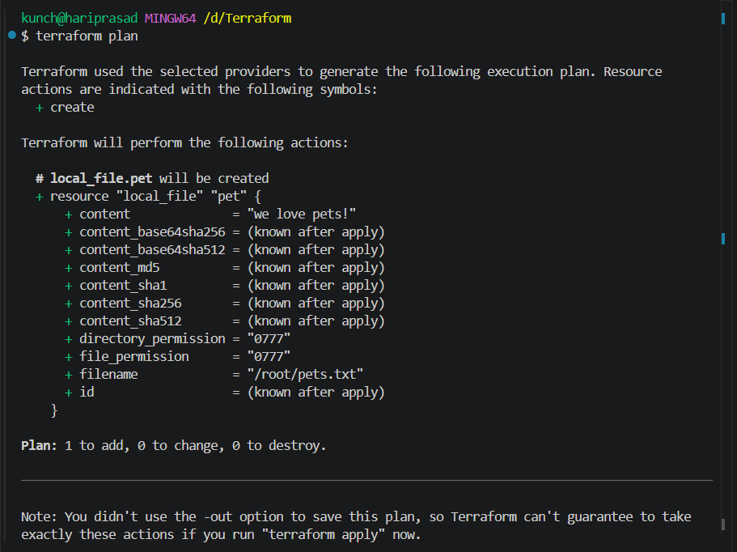
Terraform apply: Creates or updates resources according to the Terraform configuration.
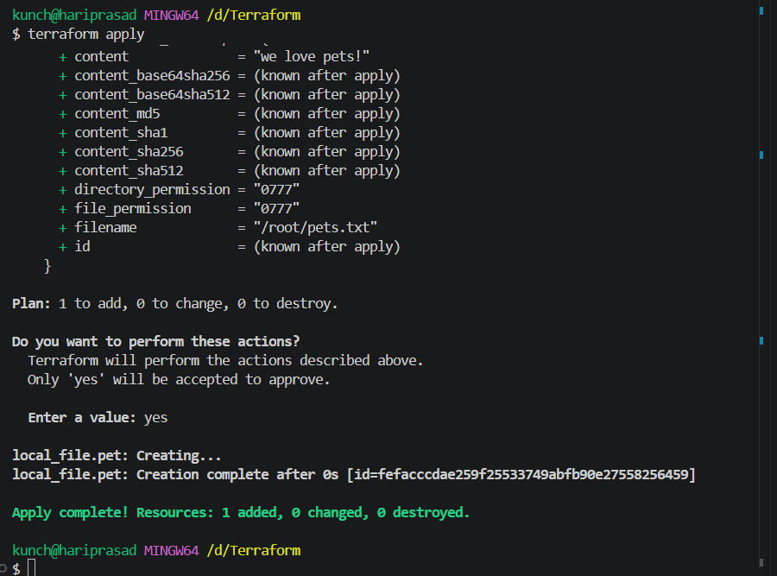

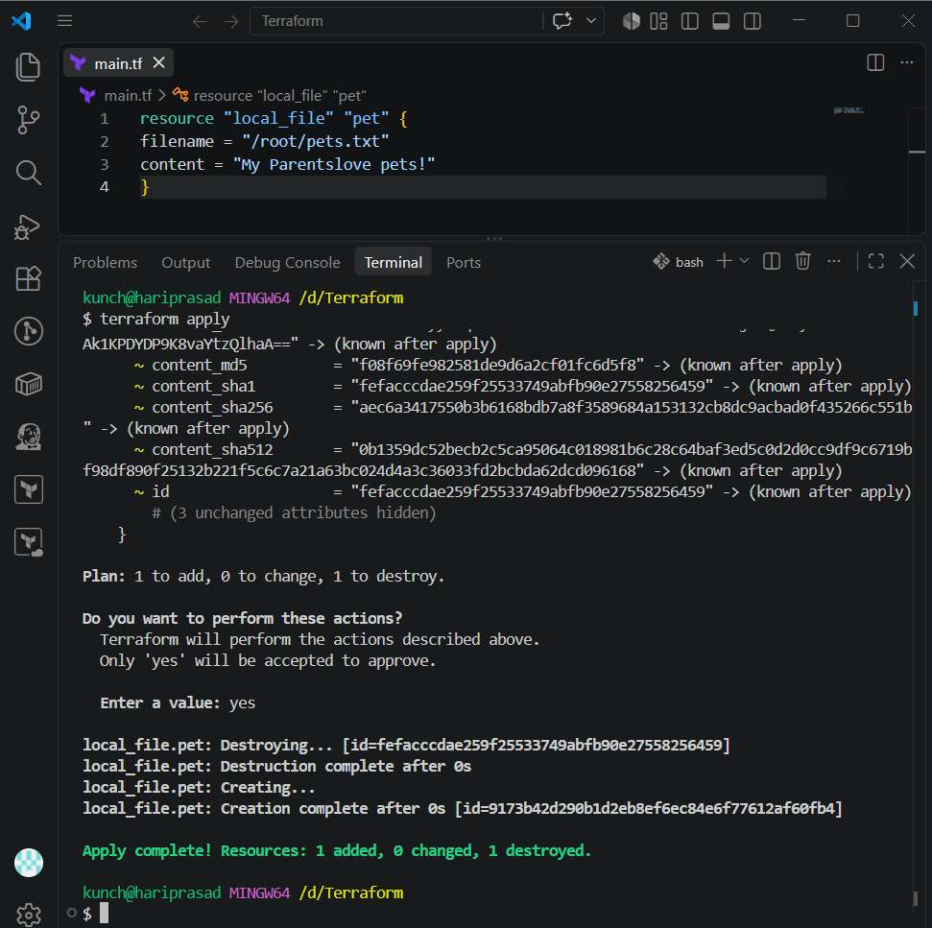
Terraform destroy: Deletes all resources managed by the current Terraform configuration.
Terraform show: Deletes all resources managed by the current Terraform configuration.
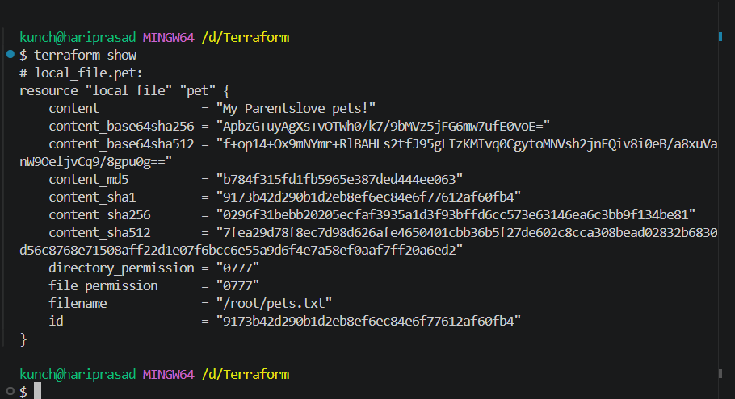
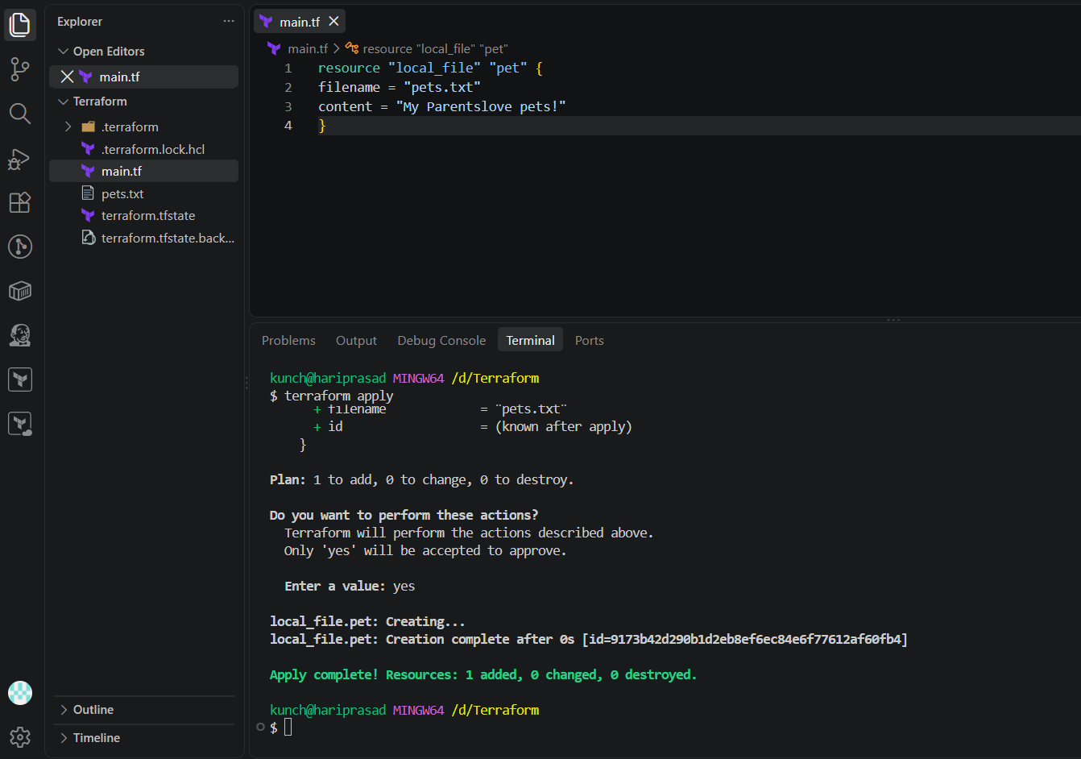
Multiple providers:
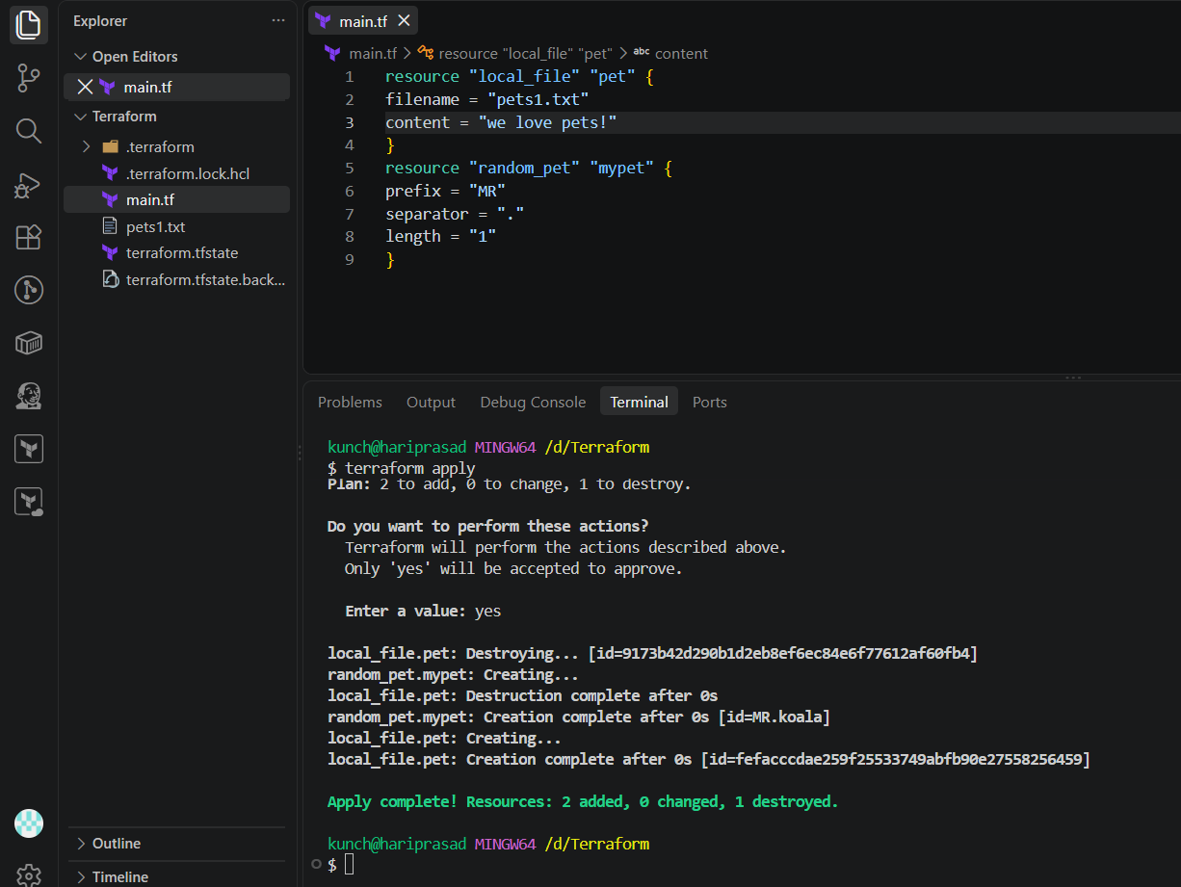
3. Note down below points, Terraform Init Terraform Plan Terraform Apply Terraform Provider.
Terraform init: Initializes the Terraform working directory and downloads required providers/modules.

Terraform plan: Shows what changes Terraform will make before creating or modifying resources.

Terraform apply: Creates or updates resources according to the Terraform configuration.



Terraform destroy: Deletes all resources managed by the current Terraform configuration.
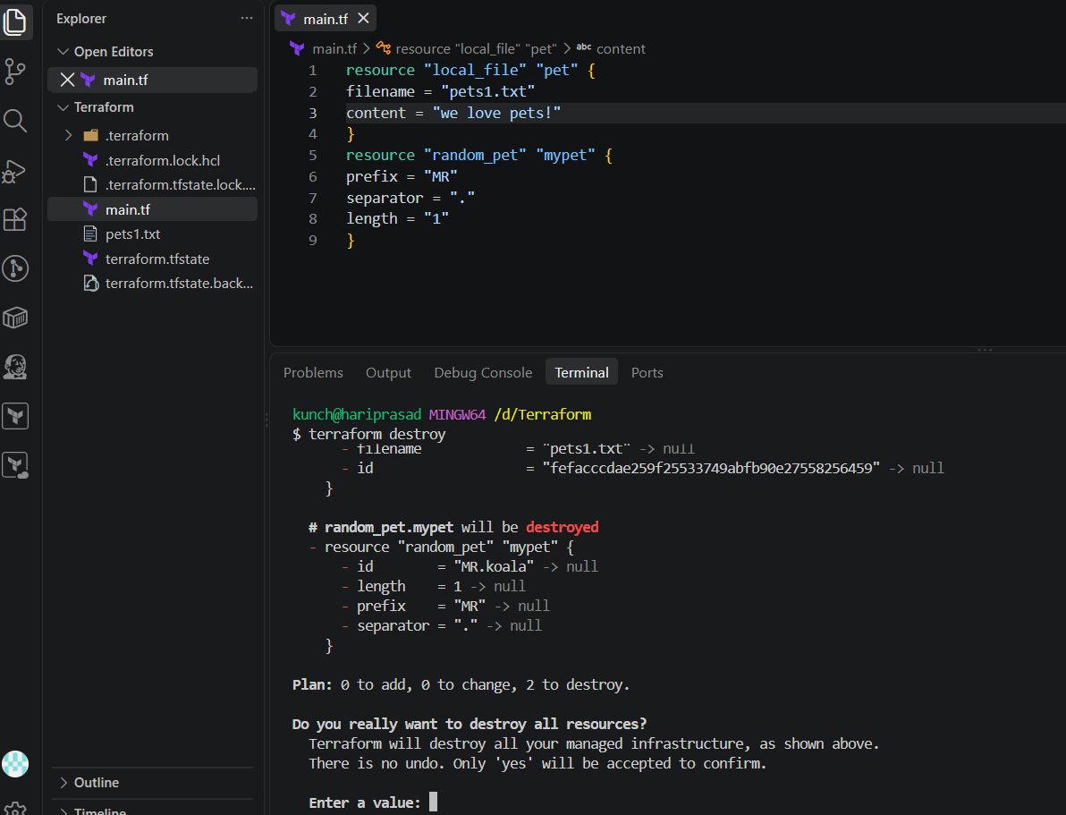
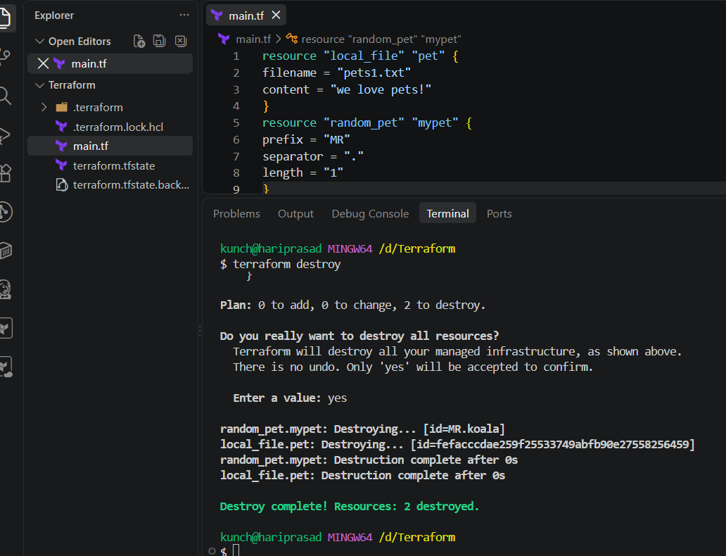
Terraform show: Deletes all resources managed by the current Terraform configuration.

4. Integrate a sample Terraform template in Jenkins.
Objective
We will configure Jenkins to execute Terraform commands automatically:
GitHub
↓
Jenkins
↓
terraform init
↓
terraform plan
↓
terraform apply
↓
AWS EC2 created
Important: Run Terraform from the machine where Terraform and AWS credentials are configured. In your practice setup, you previously specified that Terraform commands should run on Docker-Practice-Server, not the Jenkins server.

Step 1: Create Terraform project
Create a GitHub repository, for example:
terraform-jenkins-demo
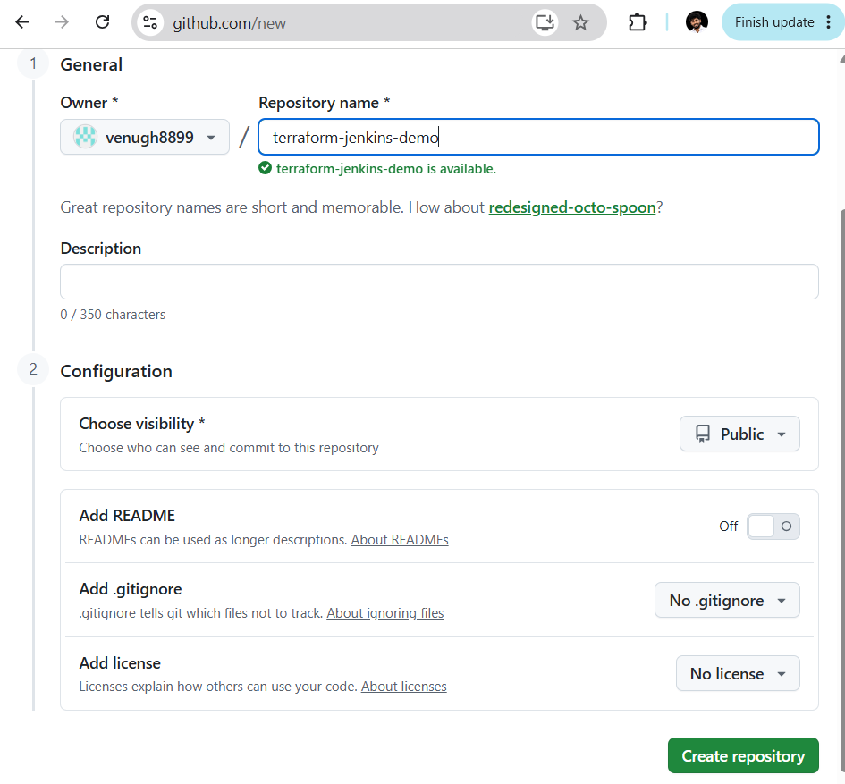
Add a file:
main.tf
Example:
terraform {
required_providers {
aws = {
source = "hashicorp/aws"
}
}
}

provider "aws" {
region = "ap-south-1"
}

resource "aws_instance" "demo" {
ami = "YOUR_AMI_ID"
instance_type = "t3.micro"

tags = {
Name = "Terraform-Jenkins-Demo"
}
}
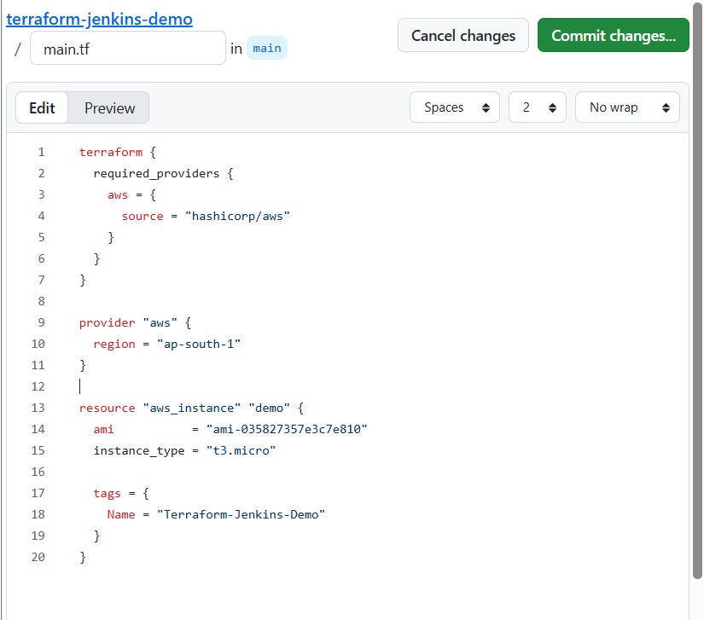
Replace:
YOUR_AMI_ID(ami-035827357e3c7e810)
with a valid Ubuntu/Amazon Linux AMI for ap-south-1.
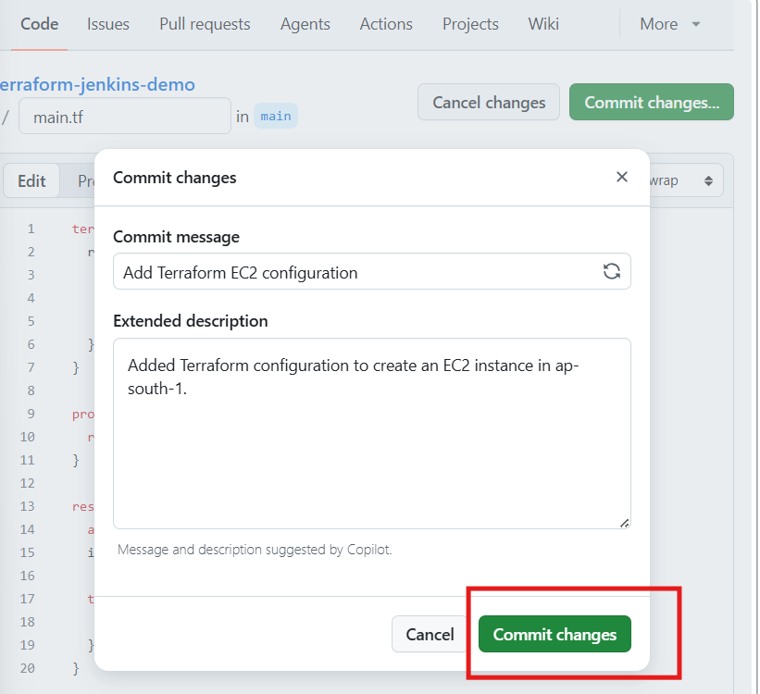

Step 2: Test Terraform manually first
On your Terraform machine:
cd terraform-jenkins-demo
Run:
terraform init
Then:
terraform plan
Then:
terraform apply
Type:
yes
Verify the EC2 instance is created.
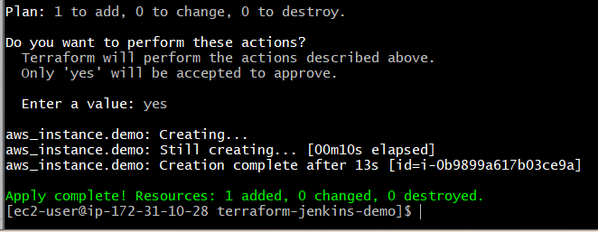

Step 3: Create Jenkins Job
Go to:
Jenkins
↓
New Item
Enter:
Terraform-Jenkins-Demo
Select:
Pipeline
Click:
OK

Step 4: Configure GitHub repository
Inside the Jenkins job:
Pipeline
↓
Definition
Select:
Pipeline script from SCM
Then:
SCM: Git
Repository URL:
https://github.com/YOUR_USERNAME/terraform-jenkins-demo.git
Branch:
*/main
Script Path:
Jenkinsfile

Step 5: Create Jenkinsfile
Create this file in your GitHub repository:
Jenkinsfile
Simple pipeline:
pipeline {
agent any

stages {

stage('Terraform Init') {
steps {
sh 'terraform init'
}
}

stage('Terraform Plan') {
steps {
sh 'terraform plan'
}
}

stage('Terraform Apply') {
steps {
sh 'terraform apply -auto-approve'
}
}
}
}
Repository:
terraform-jenkins-demo/
│
├── main.tf
└── Jenkinsfile
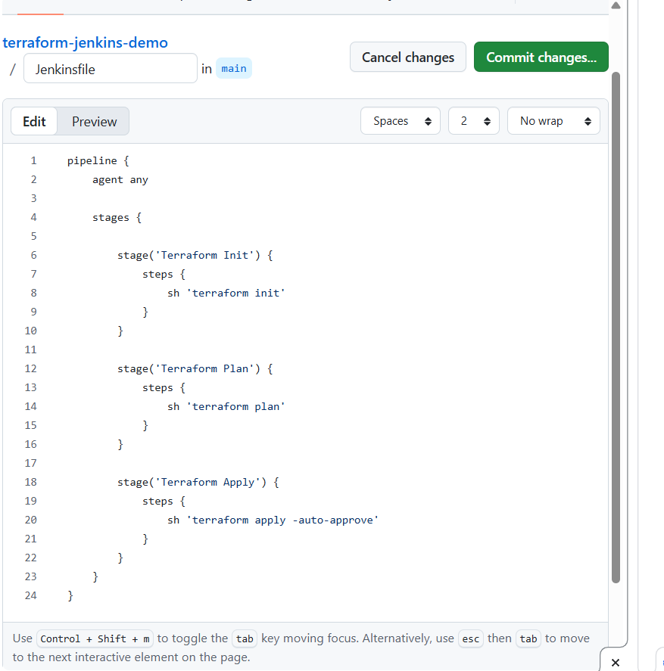

Step 6: Run Jenkins Build
In Jenkins:
Terraform-Jenkins-Demo
↓
Build Now
Jenkins will execute:
Terraform Init
↓
terraform init
↓
Terraform Plan
↓
terraform plan
↓
Terraform Apply
↓
terraform apply -auto-approve
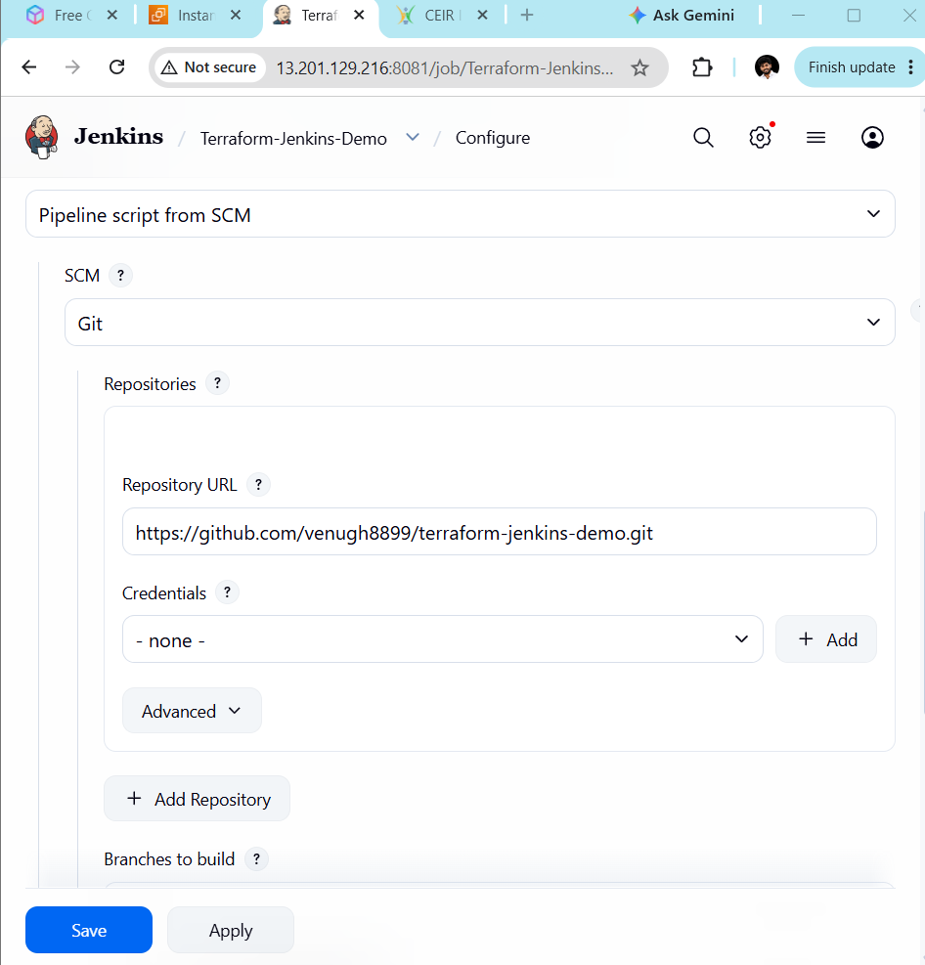

Step 7: Check Console Output
Click:
Build #1
↓
Console Output
You should see something similar to:
[Terraform Init]
terraform init

Terraform has been successfully initialized!

[Terraform Plan]
Plan: 1 to add, 0 to change, 0 to destroy.

[Terraform Apply]
Apply complete! Resources: 1 added, 0 changed, 0 destroyed.
Then check AWS EC2.
You should see:
Terraform-Jenkins-Demo
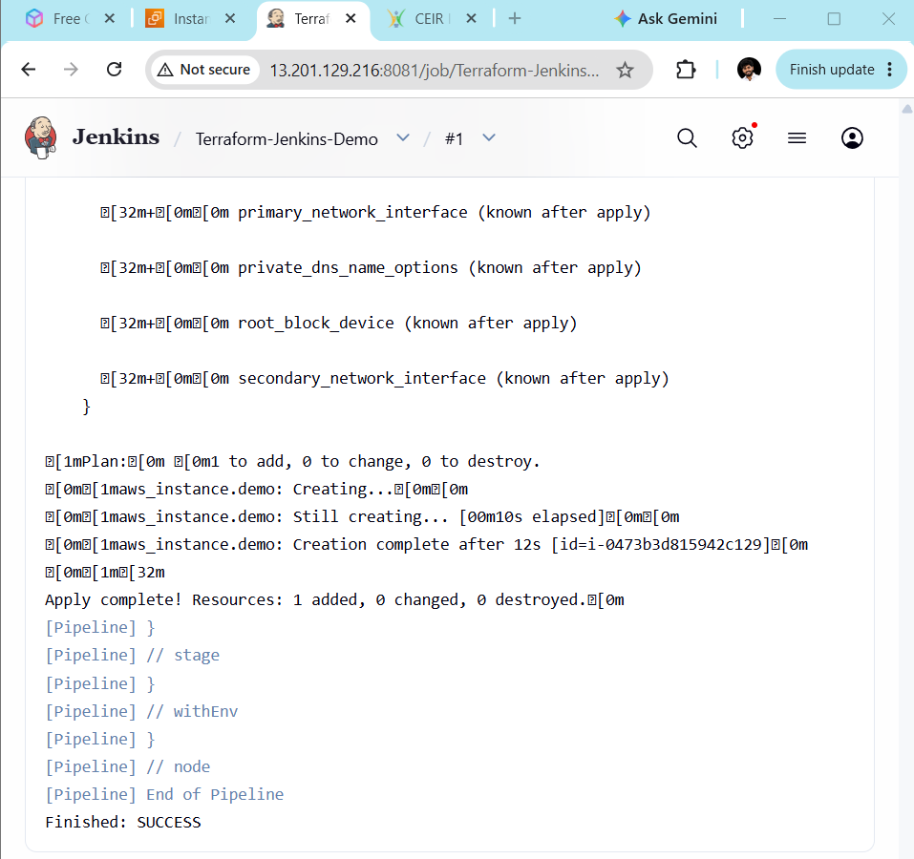

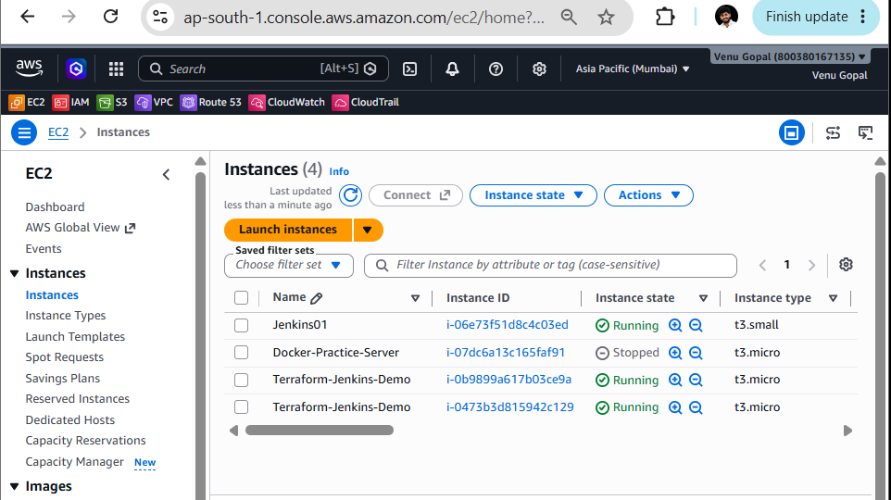

Final Jenkins Flow
Developer
│
▼
GitHub
│
│ Jenkins pulls code
▼
Jenkins
│
├── terraform init
│
├── terraform plan
│
└── terraform apply
│
▼
AWS EC2

